**I**ntelliSync **O**ffice **A**utomationLimited **(IOA)**  
“Synchronizing Your Office, Maximizing Your Productivity”

* **Company Overview**IntelliSync Office Automation Limited is an end-end leading office automation solutions provider. Seamlessly integrating software, hardware, processes, and business workflows, IOA empowers organizations to achieve higher productivity, minimize errors, and optimize resource utilization. Our tailored solutions address the unique challenges of modern workplaces—helping clients transform routine tasks into efficient, digitally driven processes.
* **Mission**  
  To enable organizations of all sizes to realize their full operational potential through innovative, reliable, and scalable office automation solutions that reduce cost, eliminate manual bottlenecks, and foster a culture of continuous improvement.
* **Vision**  
  To be the world’s most trusted partner in office automation, setting the standard for integrated technology solutions that drive productivity, accuracy, and sustainable growth for our clients.
* **Core Values**  
  • Innovation: We continuously explore emerging technologies to deliver cutting-edge solutions.  
  • Excellence: We uphold the highest standards of quality in every project.  
  • Customer Focus: We listen, anticipate needs, and customize services for lasting partnerships.  
  • Integrity: We operate with transparency, honesty, and respect in all interactions.  
  • Collaboration: We foster teamwork—both internally and with clients—to achieve shared success.
* **Service Offerings**  
  • Workflow Assessment & Consulting  
  – Business process audits to identify inefficiencies  
  – Strategic roadmaps for digital transformation  
  • Custom Software Development  
  – Document management systems  
  – Automated approval and notification workflows  
  – Data analytics and reporting dashboards  
  • Hardware Integration  
  – Scanners, printers, and multifunction devices  
  – Secure server and network infrastructure  
  • System Implementation & Integration  
  – Seamless integration with ERP, CRM, HRIS, and legacy applications  
  – API development and middleware configuration  
  • Training & Change Management  
  – User-centric training programs and documentation  
  – Stakeholder engagement and adoption support  
  • Support & Maintenance  
  – 24/7 technical support and helpdesk services  
  – Proactive monitoring, patch management, and upgrades
* **Key Differentiators**  
  • Holistic Approach: We combine software, hardware, and process expertise to deliver turnkey solutions.  
  • Scalability: Modular architecture and flexible pricing models ensure solutions grow with your business.  
  • Proven Methodology: Our phased implementation framework mitigates risk and accelerates time-to-value.  
  • Industry Expertise: Deep domain knowledge in finance, human resources, legal, and administrative functions.  
  • Security & Compliance: We adhere to industry best practices, including ISO 27001 standards and GDPR guidelines.
* **Target Markets**  
  • Small and Medium Enterprises (SMEs) seeking streamlined administrative workflows  
  • Large Enterprises requiring enterprise-grade automation across multiple departments  
  • Regulated industries (finance, legal, healthcare) with stringent compliance needs  
  • Public sector organizations focused on transparency and cost efficiency
* **Technology Partnerships**  
  IOA collaborates with leading technology vendors—Microsoft, HP, Canon, Xerox, Ricoh, IBM, and Dell etc. —to ensure best-in-class hardware and software compatibility. Our certified partnerships guarantee access to the latest innovations and specialized support.
* **Quality Assurance**  
  Quality is at the heart of every IOA engagement. From initial consultation through post-go-live support, we employ rigorous testing protocols, performance benchmarks, and customer satisfaction surveys to uphold our commitment to excellence.
* **Leadership & Expertise**  
  Our leadership team combines decades of experience in software engineering, systems integration, process improvement, and change management. Supported by certified project managers, business analysts, and technical specialists, IOA delivers results-driven solutions on schedule and within budget.

Contact Us  
IntelliSync Office Automation Limited  
P. O. Box 27346-0100, Nairobi, Kenya  
Phone: +254 722 952 138 | +254 746 657 031 | +254 735 993 939 Email: [info@intellisync-ioa.com]  
Web: [www.intellisync-ioa.com](http://www.intellisync-ioa.com/)

**Why IntelliSync Office Automation**

**IOA** leverages the use of technology to streamline and improve office tasks and workflows. By integrating Software, Hardware, Processes and Businesses to, reduce errors, and optimize resource management.

**KEY COMPONENTS   
1. Document Management**

IntelliSync Office Automation tools & systems include features that allow for easy creation, storage, retrieval, and sharing of documents. This ensures that team members have access to the latest information and reduces the risk of version control issues.

**2. Workflow Automation**

Automating workflows helps standardize processes, ensuring tasks are consistently and efficiently. This can include automating approvals, notifications, and task significantly reducing manual effort.

**3. Collaboration Tools**

IntelliSync Office Automation tools typically include collaboration features that facilitate communication among team members. This may involve shared workspaces, real-time editing, and integrated messaging systems, enhancing teamwork and project management.

**4. Data Analysis and Reporting**

Automation can streamline data collection and reporting processes. By integrating data analytics tools, businesses can easily generate insights and reports, helping to make informed decisions quickly.

**5. Integration Capabilities**

IntelliSync Office Automation tools integrate with existing systems (like **CRM, DMS, PMS, ECMS** or **ERP**, **AI Software & Hardware**, enabling seamless data transfer and reducing the need for manual data entry.

**BENEFITS OF OFFICE AUTOMATION  
1. Increased Productivity**

By automating repetitive tasks, employees can focus on more strategic work, leading to improved productivity and job satisfaction.

**2. Cost Savings**

Reducing manual processes can lead to significant cost savings in labour and operational efficiencies, allowing organizations to allocate resources more effectively.

**3. Improved Accuracy**

Automation minimizes the risk of human error, ensuring greater accuracy in data entry and processing, which is crucial for maintaining high-quality standards.

**4. Enhanced Communication**

Collaboration tools facilitate better communication and information sharing among team members, leading to faster decision-making and project execution.

**5. Scalability**

Automated systems can easily scale with business growth, allowing organizations to adapt to changing needs without significant changes to their processes.

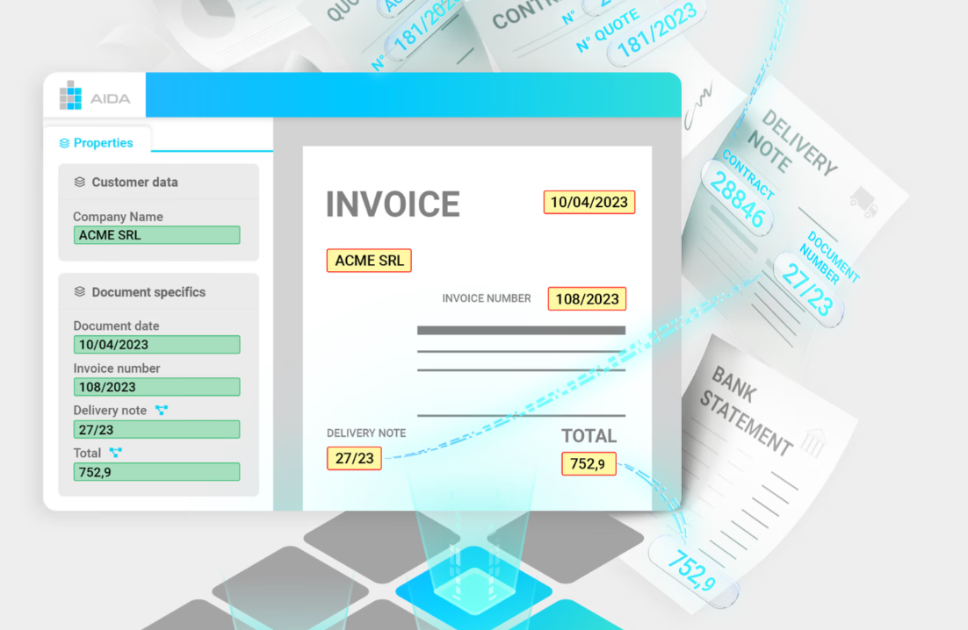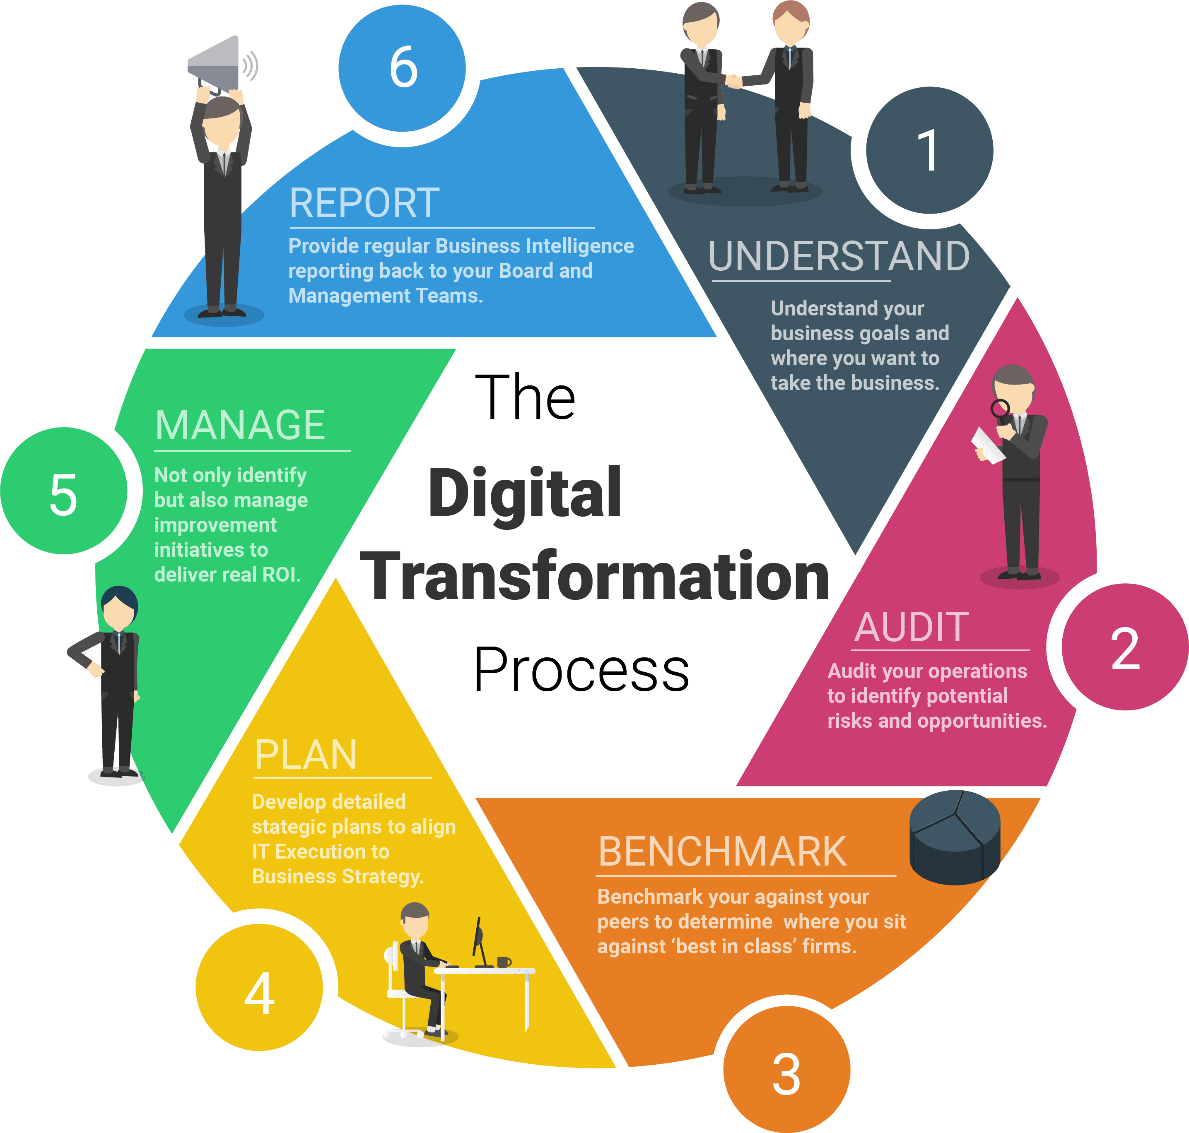

IOA is the industry-leading solution for **intelligent document processing**.

Leveraging a user-friendly point-and-click interface, IOA learns to extract **any field** from **any document** after seeing just **one example**.  
Enables you to automate archiving, task management, and Knowledge Graph creation to reveal **valuable connections** between documents and drive your organization's efficiency and insights

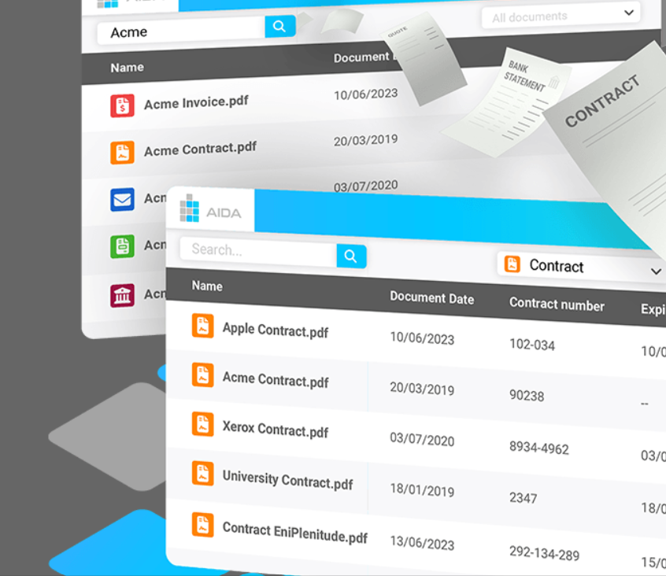 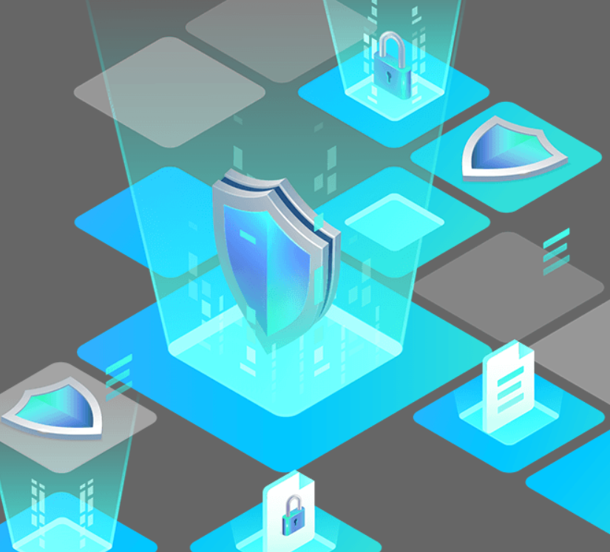

Optimize business efficiency: embrace the future with **IOA's Advanced Document Archive Security and Certifications**

Secure your digital assets and ensure data protection, compliance, and accessibility with IOA

**OUR VALUE PARTNERS**

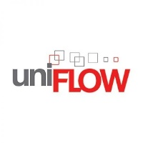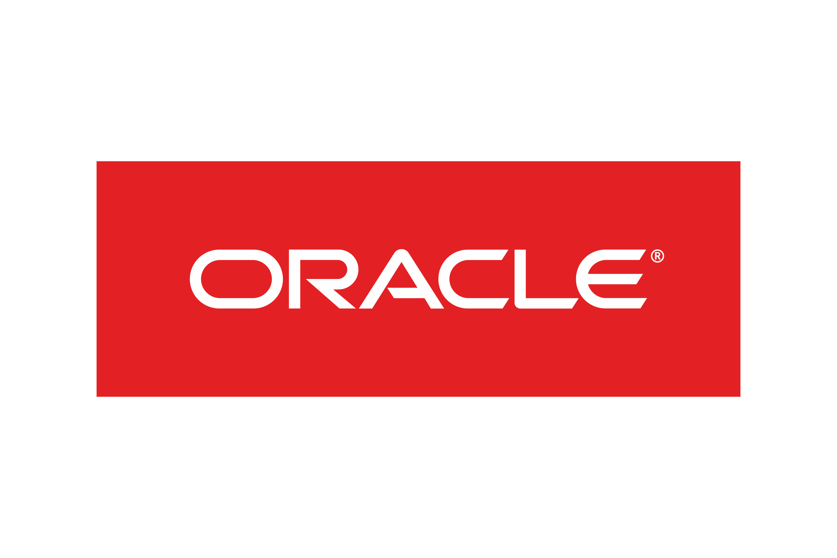Fortinet

